Project Report
On

Design & Veriﬁcation of Single Port RAM

By

Swayam Swastik Sahu


Department of Electronics and Communication Engineering

NIST University
Institute Park, Berhampur, Odisha -761008, India
www.nist.edu

Table of Contents

- Abstract

- Introduction

- Design Overview

- Verilog Code

- Testbench Design

- Simulation and Results

- Conclusion

- References

- Appendix

Abstract

This project involves the design and verification of a 64x8-bit single-port Random Access Memory (RAM) using Verilog. The RAM module is synchronous, with both read and write operations controlled by a clock signal and a write enable (we) signal. Various test cases were implemented in a Verilog testbench to verify the correct functionality of the RAM, including basic read/write operations, overwriting data, random access, and checking for uninitialized memory. The results of the simulation demonstrate that the single-port RAM design performs as expected, meeting the project’s objectives.

Introduction

Background
In digital systems, Random Access Memory (RAM) is essential for temporary data storage, allowing fast access and retrieval of data. A single-port RAM, in particular, allows both read and write operations to be performed, but only one operation at a time through a single address bus. This type of RAM is commonly used in embedded systems, processors, and data buffering applications where memory access can be controlled sequentially.

As part of this project, a single-port RAM was designed using Verilog, a hardware description language (HDL) used to model digital circuits. The main goal of this project was to implement a 64x8-bit single-port RAM module, ensuring both read and write operations are correctly performed.

    - RAM is considered as volatile memory, which means that the stored information is lost when there is no power.
    - RAM is made up of small memory chips that form a memory module.
    - Whenever you open a program, it gets loaded from the hard drive into the RAM.
    - This is because reading data from the RAM is much faster than reading data from the hard drive.

Objective
The objective of this project is to:

- Design a single-port RAM with 64 memory locations, each capable of storing 8-bit data.
- Simulate the design to verify the correct functionality using various test cases.

Scope
This project focuses on the design and verification of a basic single-port RAM using Verilog. The memory can store 64 locations of 8-bit data, and a clock-driven mechanism is used for synchronous read/write operations. The scope of this project does not include advanced features like dual-port RAM, multi-bank memory, or error-correcting code (ECC) implementation.

Design Overview

  - Single-Port RAM Architecture
The single-port RAM allows either a read or a write operation at a given time. The architecture includes:

- Data Bus (8-bit): For reading from and writing to memory.
- Address Bus (6-bit): To specify the memory location for read/write operations.
- Write Enable (we): A control signal to determine whether to read from or write to memory.
- Clock Signal: Used to synchronize all operations.

Block diagram:

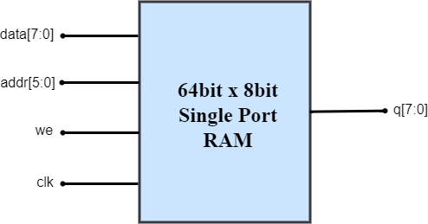

  - Key Features:
- Data Width: 8-bit data for each memory location.
- Address Width: 6-bit address, enabling access to 64 locations.
- Write Enable: A control signal that allows data to be written when high (we = 1), or read when low (we = 0).
- Synchronous Operation: Both read and write operations are synchronous with the clock signal.

Verilog Code

Single-Port RAM Design Code:

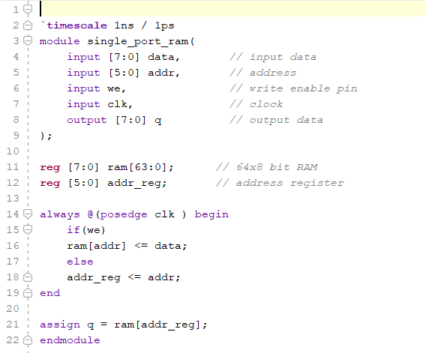

Code Explanation:

- Module Definition (single_port_ram): This is a Verilog module that implements a single-port RAM.
- Inputs:
  - data [7:0]: 8-bit input data to be written into the RAM.
  - addr [5:0]: 6-bit address input, allowing access to 64 memory locations.
  - we: Write enable signal. When high, data is written to the RAM at the specified address.
  - clk: Clock signal, used to trigger the data writing and address storing operations.
- Output:
  - q [7:0]: 8-bit output, which holds the data read from the RAM.
- RAM Declaration:
  - reg [7:0] ram [63:0]: A 64 x 8-bit memory array is declared, where each of the 64 memory locations stores 8-bit data.
- Address Register:
  - reg [5:0] addr_reg: A register to store the address during a read operation. It holds the address from which data is read in the next cycle.
- Sequential Block:
  - The always @(posedge clk) block triggers on the rising edge of the clock.
  - Write Operation:
    - If the we (write enable) signal is high (1), the input data is written into the memory location specified by the addr.
  - Read Operation:
    - If we is low (0), the current address value from addr is stored in addr_reg.
- Data Output Assignment:

  - The output q is continuously assigned the data stored in the memory location addressed by addr_reg from the last read cycle.

RTL Schematic:

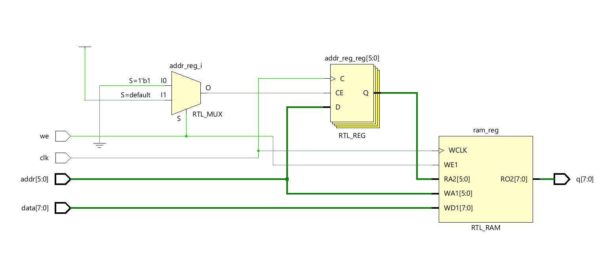

Figure 1: Schematic of Single Port RAM

- Testbench Design

Testbench Code:
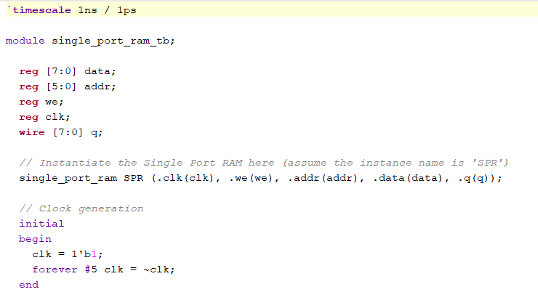

Code Explanation:

- Module Declaration:
  - The module single_port_ram_tb is declared for testing the single_port_ram module.
- Inputs/Outputs:
  - reg [7:0] data: 8-bit register to hold the input data for the RAM.
  - reg [5:0] addr: 6-bit register to hold the address to
access the RAM locations.
  - reg we: A register for the write enable signal.
  - reg clk: A register for the clock signal.
  - wire [7:0] q: Wire to capture the 8-bit output from the RAM.
- Instantiation of the RAM:
  - The single_port_ram module is instantiated as SPR, connecting the input and output signals to the testbench’s data, addr, we, clk, and q.
Clock Generation:

- Clock Initialization:
  - clk=1'b1;: The clock is initialized to 1 (high) at the start.
  - forever #5 clk = ~clk;: The clock toggles every 5 time units, creating a clock period of 10 time units.
- 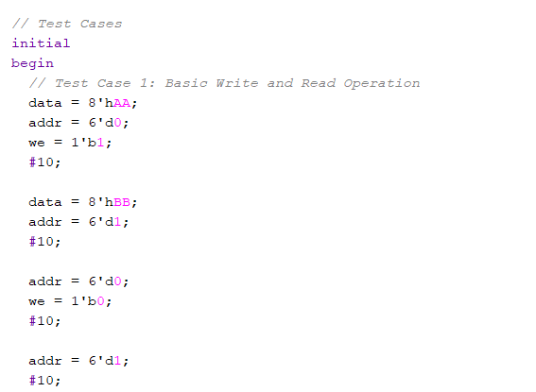

Test Cases:

  - The initial block defines various test scenarios to verify the correct functionality of the single-port RAM.

Test Case 1: Basic Write and Read Operation

- Write 8'hAA to address 0.
- Write 8'hBB to address 1.
- Read from address 0 and 1 by setting we = 0 (disabling write mode).

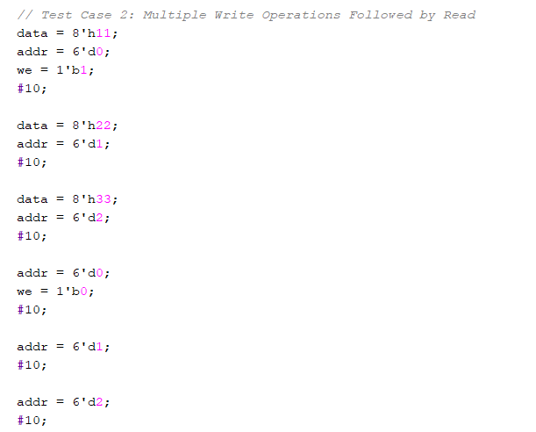

Test Case 2: Multiple Write Operations Followed by Read

- Write 8'h11, 8'h22, and 8'h33 to addresses 0, 1, and 2, respectively.
- Read the data back from addresses 0, 1, and 2.

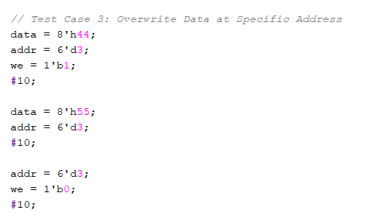

Test Case 3: Overwrite Data at a Specific Address

- Write 8'h44 to address 3.
- Overwrite with 8'h55 at the same address 3.
- Read the value from address 3 to verify the overwrite.

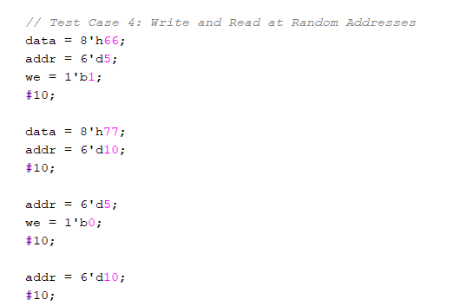

Test Case 4: Write and Read at Random Addresses

- Write 8'h66 to address 5 and 8'h77 to address 10.
- Read from the same addresses (5 and 10) to verify the data.

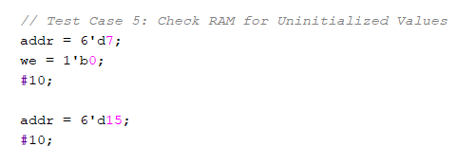

Test Case 5: Check RAM for Uninitialized Values

- Check data from address 7 and address 15 without initializing them (to test uninitialized memory locations).

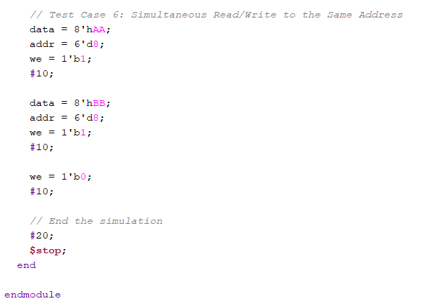

Test Case 6: Simultaneous Read/Write to the Same Address

- Write 8'hAA to address 8 and then immediately overwrite with
8'hBB at the same address.
- Read the data from address 8 to check if the overwrite was successful.
- Ending the Simulation:

  - After running the test cases, the simulation is stopped with
$stop after a delay of 20ns.

This testbench simulates different scenarios like write, read, overwriting, and random access operations to verify the functionality of a single-port RAM.

Simulation Output

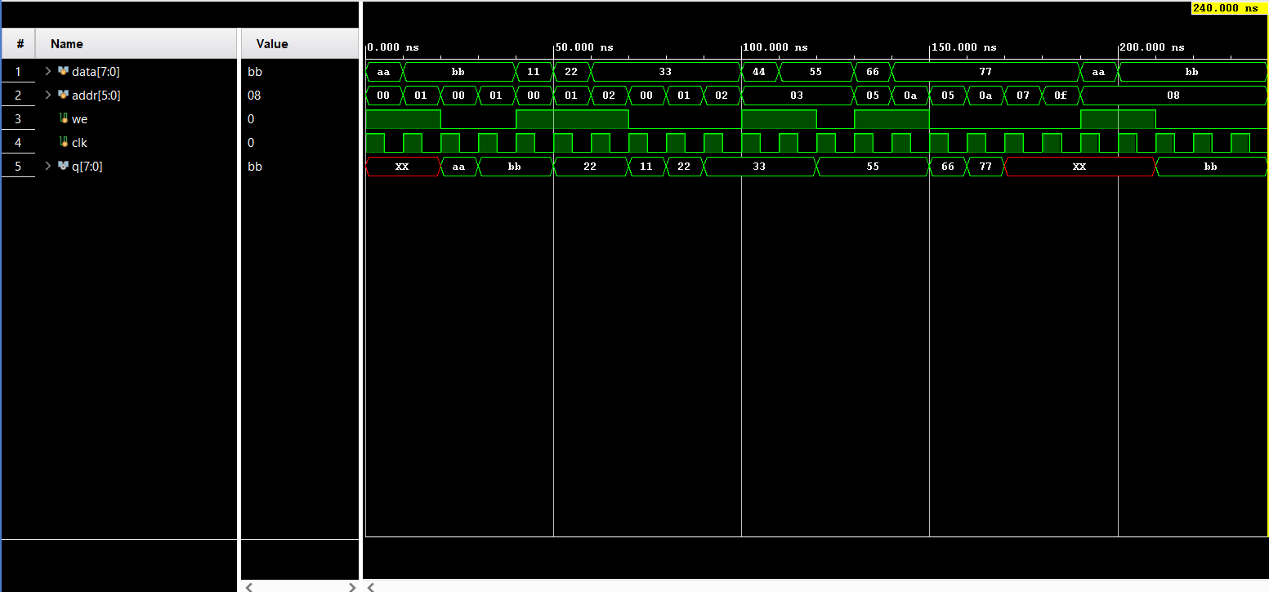

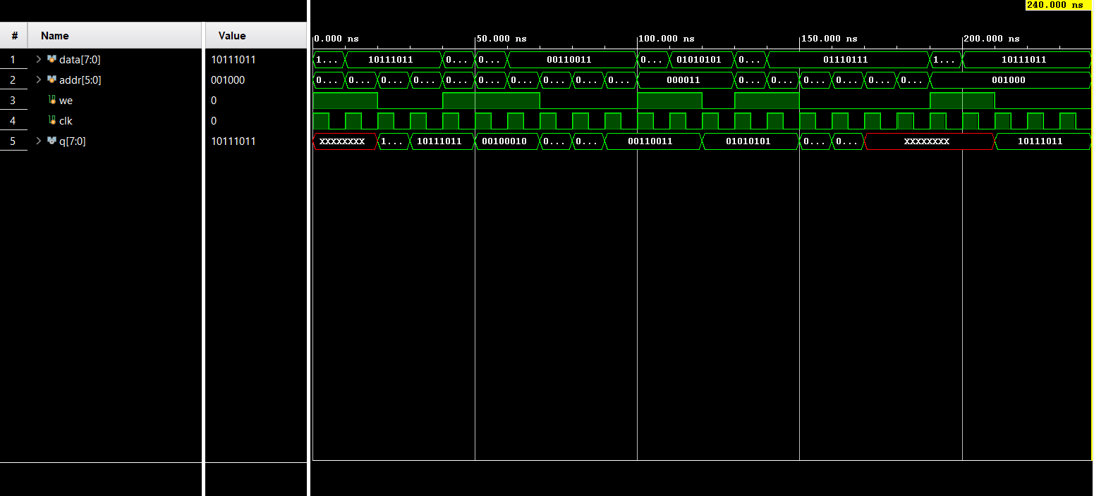

- Conclusion

The design and verification of a single-port RAM using Verilog was successfully completed. The RAM was tested under various conditions, and the design met the expected functionality, including correct read/write operations and random access. Future work could include expanding the design to dual-port RAM or adding error detection and correction mechanisms.

References

- Tools : Vivado
- Hardware Description Language : Verilog

Appendix

The full Verilog code for the Single-Port RAM implementation, including the main module and testbench, can be accessed on GitHub. For detailed code listings and further implementations, please visit the following repository:

GitHub Repository:

THANK YOU !!

